1. Sigmoid (Logistic) Activation Function
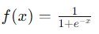
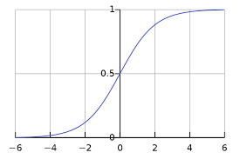
Advantages:
- Smooth gradient: Helps with gradient-based optimization methods.
- Output range: (0, 1), which can be interpreted as probabilities.
Disadvantages:
- Vanishing gradient problem: For very high or very low input values, the gradient becomes very small, which can slow down the training.
- Outputs not zero-centered: This can slow down convergence during gradient descent.
Usage Recommendations:
- Sigmoid: Historically used but less common now due to the vanishing gradient problem.

2. Hyperbolic Tangent (tanh) Activation Function
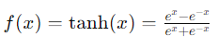
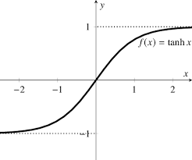
Advantages:
- Zero-centered: The outputs range from -1 to 1, which can help with convergence.
- Smooth gradient: Like the sigmoid, it provides a smooth gradient.
Disadvantages:
- Vanishing gradient problem: Similar to sigmoid, though less severe.
Usage Recommendations:
- Tanh: Historically used but less common now due to the vanishing gradient problem.

3. Rectified Linear Unit (ReLU) Activation Function
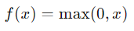
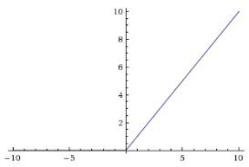
Advantages:
- Computationally efficient: Only requires a threshold at zero.
- Sparse activation: A portion of neurons are deactivated, promoting sparsity and efficient computation.
- Alleviates vanishing gradient problem: Increases the convergence rate of gradient descent.
Disadvantages:
- Dying ReLU problem: Neurons can sometimes get stuck during training and output zero for all inputs. This can be mitigated using variants like Leaky ReLU.
Usage Recommendations:
- ReLU: The default choice for most deep learning models due to its simplicity and effectiveness.

4. Leaky ReLU Activation Function
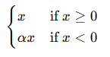
f(x)=max (αx, x)
Where α is a small constant, typically 0.01.
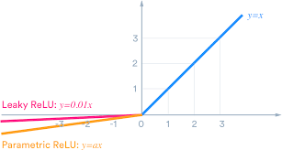
Advantages:
- Solves dying ReLU problem: Allows a small, non-zero gradient when the unit is not active.
Disadvantages:
- Computationally slightly less efficient: Due to the added multiplication.
Usage Recommendations:
- Leaky ReLU: Used when the dying ReLU problem is encountered.

5. Parametric ReLU (PReLU) Activation Function
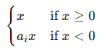
f(x)=max (α_{i} x, x)
Where α_{i} is a parameter learned during training.

Advantages:
- Adaptive: The parameter α\alphaα can be learned to best fit the data.
Disadvantages:
- Increased computational cost: Due to learning an additional parameter.
Usage Recommendations:
- PReLU: Used when the dying ReLU problem is encountered.

6. Exponential Linear Unit (ELU)
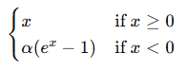
f(x)=max (α(e^{x} - 1), x)
where α is a positive constant that determines the value to which an ELU saturates for negative net inputs.
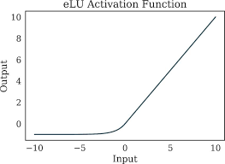
Advantages:
- Improves learning characteristics: Combines the benefits of ReLU and leaky ReLU.
- Smooth gradient: Reduces the vanishing gradient problem.
Disadvantages:
- Computational cost: More complex than ReLU.
Usage Recommendations:
- ELU: Can be used when additional performance is needed, and computational resources allowed.

7. Swish Activation Function
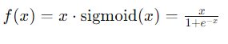
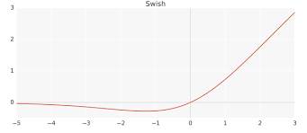
Advantages:
- Smooth and non-monotonic: Often outperforms ReLU on deep networks.
Disadvantages:
- Computationally more expensive: Due to the combination of multiplication and sigmoid function.
Usage Recommendations:
- Swish: Can be used when additional performance is needed, and computational resources allowed.

8. Usage Recommendations:
- Sigmoid and Tanh: Historically used but less common now due to the vanishing gradient problem.
- ReLU: The default choice for most deep learning models due to its simplicity and effectiveness.
- Leaky ReLU / PReLU: Used when the dying ReLU problem is encountered.
- ELU and Swish: Can be used when additional performance is needed and computational resources allow.
